**Steps to setup Functional Automation solution in Local**

1. Get Keylent github access

<https://github.com/Keylent-Inc/bethss-functional-tests>

1. Download and Install Git HUB desktop (GUI) or Git bash

<https://desktop.github.com/>

1. Connect the Github repository and clone the solution to local folder from GitHub desktop

* File >> Colne repository
* Enter Github location <https://github.com/Keylent-Inc/bethss-functional-tests.git>
* Choose your local path

1. Once clone successful then change the current Branch to Master
2. Open local solution in Visual studio

* File >> Open >> Project/Solution
* Select Bethss.Functional.Tests.sln file under bethss-functional-tests from Local

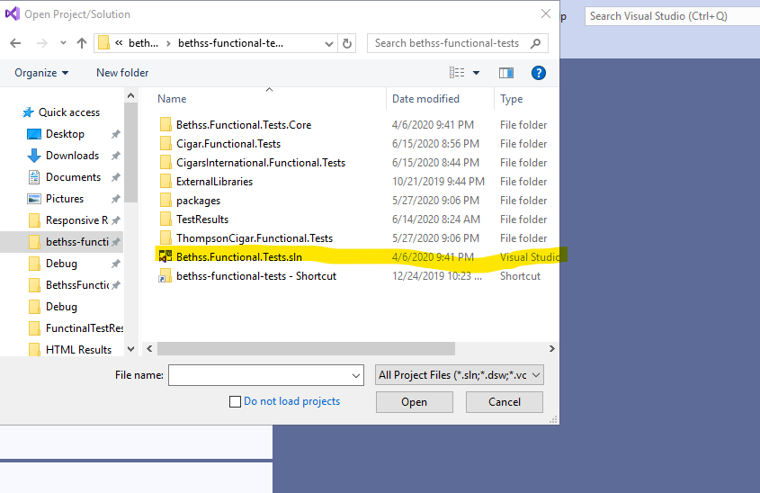

1. Install Specflow extension for Visual studio

* Select Manage Extensions option under Visual studio extensions
* Search Specflow for visual studio and install

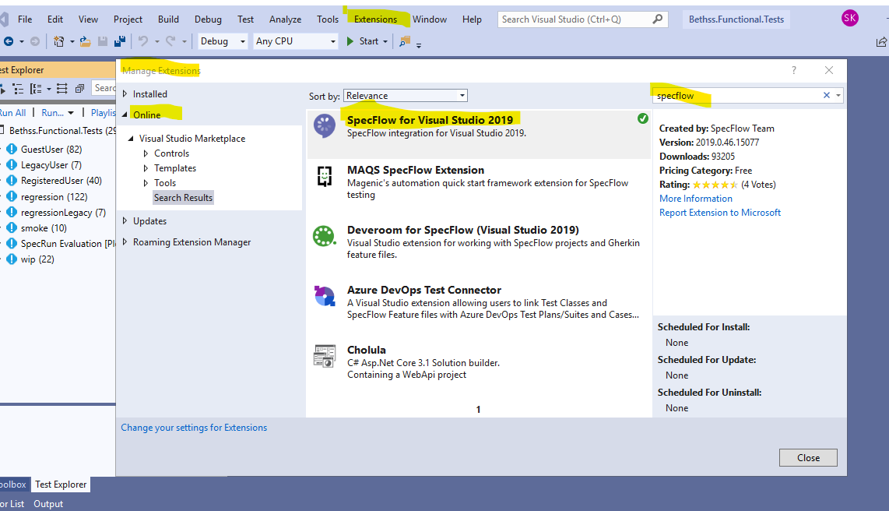

1. Open Visual studio Test explorer from Visual Studio Test >> Windows

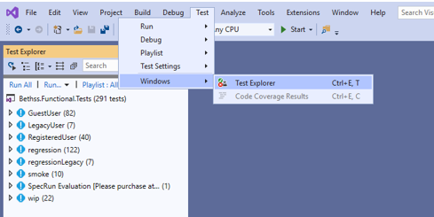

1. Build/Rebuild the solution

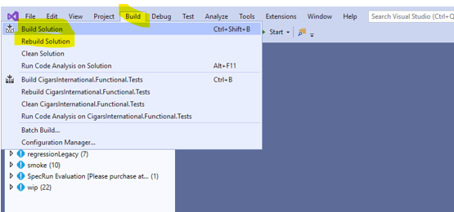

1. Tests will be displayed in Test explorer after successful build

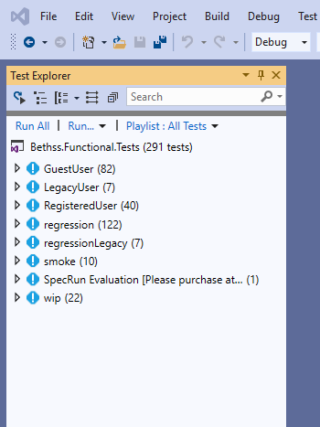

1. You can change the test explorer view by changing group by filter in test explorer

* Class – will show tests group by feature group
* Project – will show tests group by projects
* Traits – will show tests group by tags (Regression, smoke…)
* Outcome – will show results group by tests run status (pass/fail/notrun..)

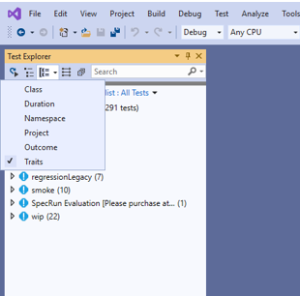

**Running Tests:**

We have couple of options to run tests.

**Option1:** Run tests from Visual studio Test explorer

Right click on any test or feature or trait and select “Run selected tests” option

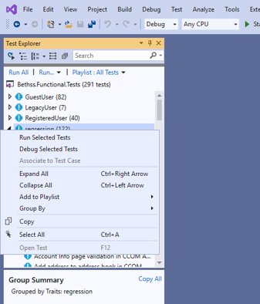

**Option2:** Run tests from Command Prompt

Open Command prompt from windows start menu and enter below command with local folder path

**Command**: <Packages folder path from your local solution >\ SpecRun.Runner.1.7.2\tools\specRun.exe run default.srprofile /baseFolder:<Debug folder path of the project you want to execute tests> /filter:"Trait" /log:specrun.log

EX: C:\Workspace\bethss-functional-tests\bethss-functional-tests\packages\SpecRun.Runner.1.7.2\tools\specRun.exe run default.srprofile /baseFolder:C:\Workspace\bethss-functional-tests\bethss-functional-tests\Cigar.Functional.Tests\bin\Debug /filter:" @regression" /log:specrun.log

Note: Result will be stored in Debug folder of the project